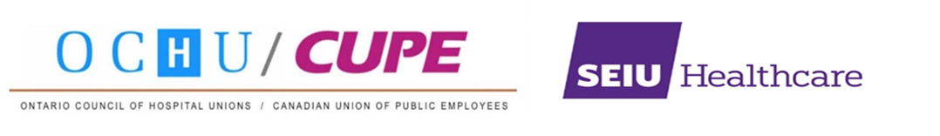

FOR IMMEDIATE RELEASE MEDIA ADVISORY January 5, 2022

Ontario union and opposition leaders to call for emergency recall of legislature, urgent action on health staffing crisis at media conference Thursday

TORONTO, ON – Union leaders from SEIU Healthcare and CUPE/OCHU will be holding a virtual press conference with all three leaders of the opposition (NDP, Liberal, and Green) to call on Premier Ford’s government to immediately recall the legislature for an emergency session to confront the harsh reality of the province’s health staffing crisis starting with the urgent repeal of Bill 124.

As COVID-19 hospitalizations in Ontario rapidly rise, reaching over 2000 on Wednesday, urgent action is needed to address a provincial healthcare system in crisis.

DATE: Thursday, January 6, 2022

TIME: 9:00 a.m.

PARTICIPANTS:
Sharleen Stewart, President, SEIU Healthcare
Michael Hurley, President, Ontario Council of Hospital Unions (CUPE/OCHU)
Andrea Horwath, Leader, Ontario New Democratic Party
Steven Del Duca, Leader, Ontario Liberal Party
Mike Schreiner, Leader, Green Party of Ontario

MEDIA LINK: https://us06web.zoom.us/j/83351035301

-30-
For information contact:

Stella Yeadon, CUPE Communications, 416-559-9300, syeadon@cupe.ca
Corey Johnson, SEIU Healthcare Communications, 416- 529-8909, c.johnson@seiuhealthcare.ca

lf/cope491

